Project Report Requirements

Chapter Title | Section Title | Guidelines | Mapping
Abstract | N/A | A paragraph summarizing the entire report. You can write a good abstract by writing 1-2 sentences summarizing each section of the report: 1-2 sentences for the motivation and problem, 1-2 sentences for your methodology, 1-2 sentences for your testing and results, and 1-2 sentences for your conclusions and takeaways. | Student outcome 3 requires students to be able to communicate with a range of audience. Abstracts and executive summaries are typically used by decision makers to quickly digest the report. The quality of the abstract can be used to assess the outcome.
Introduction | Motivation | A paragraph identifying the motivation behind the project. Why design a solution? How will this make the world better? What are the benefits? | Student outcome 1 requires students to identify complex engineering problems. Also, the definition of Engineering Design requires students to identify opportunities.
Introduction | Problem Statement | A clear and concise paragraph describing the problem that your team is trying to solve. | Student outcome 1 requires students to formulate complex engineering problems. Also, the definition of Engineering Design requires students to identify opportunities.
Introduction | Literature Review | Multiple paragraph analyzing existing solutions found in good literature. You look at existing systems and analyze them. What do they do? What are their advantages and disadvantages? | The definition of Engineering Design requires students to perform analyses. Part of analyzing problems is investigating existing solutions and their limitations.
Design | Requirements, Constraints, and Considerations | A list of all design requirements and constraints developed from the project statements, discussion with the TAs, discussion with the faculty supervisor, or the end users. Consider the list given under the definition of Engineering Design.  Another list of (1) considerations made to public health, safety, and well-being, and (2) global, social, cultural, environmental, and economic factors. | Student outcome 2 requires students to apply engineering design to produce solutions that meet specified needs and consider public health, safety, well-being, global, social, cultural, environmental, and economic factors.
Design | Design Process | A description of the iterative process followed to reach the final design. The process typically looks like this:-  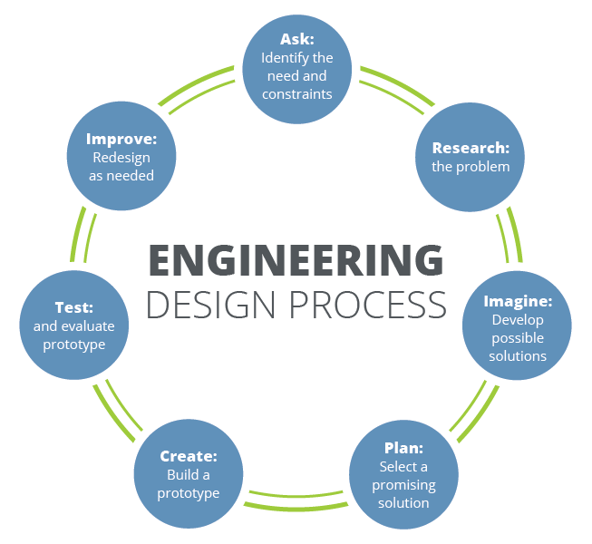  Figure 1 Engineering Design Process. Figure reproduced from: https://www.teachengineering.org/k12engineering/designprocess  Describe the process you followed. What are the alternative solutions considered? Why did you select the final design? Did you develop a first prototype? How did you refine the prototype after testing it? | Student outcome 2 requires students to apply engineering design. Also, the definition of Engineering Design requires students to generate/consider multiple possible solutions.
Design | System Overview | A diagram describing the proposed solution components and connectors linking these component. A paragraph accompanying the diagram and describing to the reader how the system work/is-designed. This is a top level design (aka architectural design).  An example figure looks like:  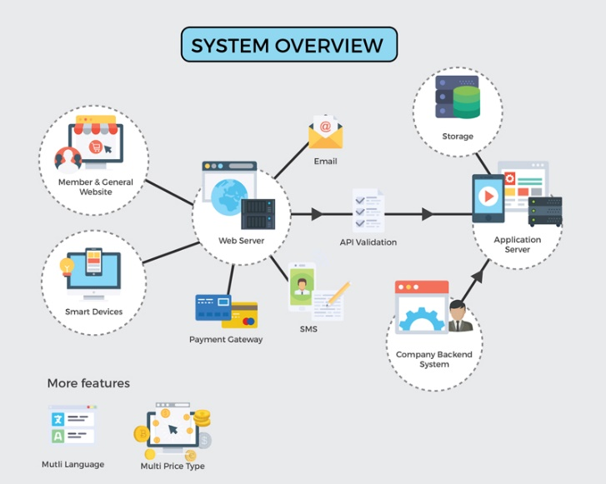 | Student outcome 1 requires students to solve complex engineering problems.
Design | Component Design | These are multiple sections with figures, tables, derivations, calculations, algorithms, and formulas describing/detailing/designing the sub-systems or sub-components of the overall system. | Student outcome 1 requires students to solve complex engineering problems.
Experimental Testing and Results | Testing Plan and Acceptance Criteria | Testing Plan: 3-5 pre-designed test cases. Test cases look like the following:  - Test Name: a name to recognize the test  - Test Description: a paragraph detailing the purpose of the test.  - Steps: steps followed during the experiment/test.  - Expected Results: what should we observe?  - Observed Results: what did we observe?  - Acceptance Criteria: how will we know the test is successful?  - Test Result: Pass/Fail result after the test is done. | Student outcome 6 requires students to develop and conduct appropriate experimentation.
Experimental Testing and Results | Results | Paragraphs with pictures, tables, measurements, and performance evaluations obtained through testing. A summary of the findings. | Student outcome 6 required students to analyze and interpret data from experimentation.
Experimental Testing and Results | Analysis and Interpretation of Data | Did the system work? Why? Did it not work? Why? What does the data tell us? Based on the data, how can we improve the system? Did we meet the criteria (important)? How so?
Conclusion | Summary | A summary of the entire report. This summary is focused on the methodology and results. | Student outcome 6 requires students to use engineering judgement to draw conclusions.
Conclusion | Future Improvements and Takeaways | What did we learn? What are the takeaways? How was this project useful? How do you evaluate the entire experience?
Conclusion | Lessons Learned | What new knowledge did you acquire and apply in this project? Did you use a new technology? Did you go over a tutorial teaching you something new? Did you research about a topic and ended up applying what you learned? Did you learn something by experimenting in the lab? Did you learn something from your failed attempts? | Student outcome 7 requires students to acquire and apply new knowledge using appropriate learning strategies?
Conclusion | Team Dynamics | - Who was the team leader? What evidence of good leadership can you provide?  - How did you create a collaborative and inclusive environment? Were all members engaged? How did the team communicate/collaborate? Did you create a WhatsApp group? Met in the library? Met in the lab? Communicated by emails? Where all members in attendance? Did you take meeting minutes?  - What goals did you set for your team?  - How did you plan the tasks? Did you use a Gantt Chart. Did you track your progress and update your tasks?  - Did you meet your objectives?  More information:  Goals vs. Objectives: a team goal is a broad statement describing what does the team want to achieve. For example, a goal can be to design a low-cost robot capable of winning the sumo robot competition.  Objectives are measurable steps you take towards reaching your goal. For example,  - Procure equipment by mid-October.  - Design a robot chassis weighing 1kg using renewable material.  - Design a PCB no more than 3cm by 2cm to reduce the number of flying wires to 2 as a maximum.  A Gantt Chart: a figure indicating the tasks, their dependencies, their required efforts, and who’s responsible for them?  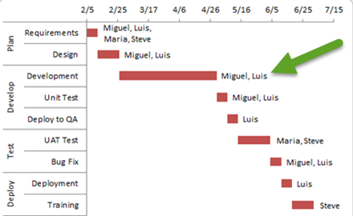  Figure 2 Example Gantt Chart - Reproduced from https://www.exceldashboardtemplates.com/add-resource-names-excel-gantt-chart-tasks/ | Student outcome 5 requires students to function effectively on a team whose members together provide leadership, create a collaborative and inclusive environment, establish goals, plan tasks, and meet objectives
Conclusion | Impact Statement | What is the impact of your engineering solution on the economy, the environment, and the society?  - Does your solution help society? How?  - Are there any privacy concerns for the users?  - Will your solution create jobs? Remove jobs from the market?  - Will the electronics from your project end up being electronic waste? How did you reduce this? What impact does your system have on the environment? Does it reduce dependency on fossil fuel? Is it sustainable?  - Does your system reduce energy demand? Increase energy demand? By how much? Is it still worth it?  - Does your system provide comparable performance to existing one while reducing the cost? Reducing the power consumption? Reducing the environmental footprint?
References | N/A | Was all pre-existing work including (code, figures, summaries, methodologies, … etc.) properly credited and cited? Is the style of the citation correct? Are the quality of the citations good (recent, good source)? | Student outcome 4 requires students to recognize ethical and professional responsibilities in engineering situations and make informed judgments

